**Module 7 – Interfacing Keypad with Arduino Uno**

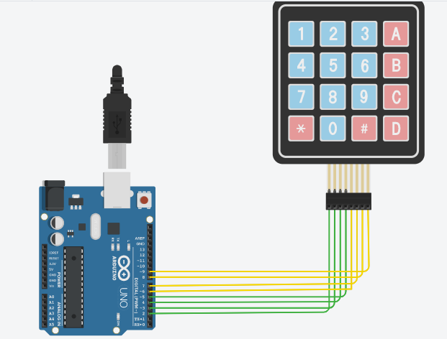

Code:

